Healthcare Analytics and Hospital Operations Intelligence Using Python and Power BI
1. Project Overview and Objective
This project focuses on analyzing healthcare and hospital operational data to identify important patterns, performance gaps, and areas for improvement. The project uses Python for data cleaning, pre processing, validation, and exploratory analysis, and Power BI for data modelling , visualization, KPI analysis, and interactive dashboard development.
The main objective is to demonstrate data pre-processing techniques using python and an interactive Power BI dashboard visualization to make informed decisions.

2. Data Sources
- Source: Hugging Face Datasets
- Year / Timeline: Data collected during 2024–2025

3. Problem Statement
- To analyse patient demographics and admission patterns across departments and wards.
- To evaluate health-condition and severity patterns among admitted patients.
- To assess hospital operational efficiency by analysing patient volume, staff availability, room availability across departments and wards.
- To analyse patient length of stay and estimated discharge dates to understand patient flow, and support hospital resource planning.
- To analyse insurance types and admission deposit patterns to understand financial aspects of patient admissions.
- To perform data cleaning, pre processing, validation and exploratory data analysis using Python.
- To develop an interactive Power BI dashboard presenting healthcare and hospital operational KPIs, trends, and actionable insights to support management decision-making.

4. Attribute (Column /Features) Details:
Attribute Name | Data Type | Description
Patient ID | Integer / String | Unique identifier for each patient
Admission Date | Date / Date time | Date on which the patient was admitted to the hospital
Age | | Numeric (Integer) | Age of the patient in years
Gender | Categorical (String) | Gender of the patient
Department | Categorical (String | Medical department handling the patient
Ward | Categorical (String) | Ward or unit where the patient is assigned
Admission Type | Categorical (String) | Mode of admission (e.g., Emergency, Urgent, Elective)
Severity | Categorical / Ordinal | Severity level of the patient's medical condition
Health Condition | Categorical (String) | Primary diagnosis or health condition of the patient
Staff Available | Numeric (Integer) | Number of healthcare staff available during admission
Available Rooms | | Numeric (Integer) | Number of rooms available in the ward/facility
Visitors | Numeric (Integer) | Number of visitors allowed or recorded for the patient
Insurance Type | Categorical (String) | Type of health insurance held by the patient
Admission Deposit | Numeric (Float) | Initial deposit amount paid at the time of admission
Length of_ Stay Days | Numeric (Integer) | Total duration of hospital stay in days
Admission Year | Numeric (Integer) | Year component of the admission date
Admission Month | Numeric (Integer / String) | Month component of the admission date
Admission Day | Numeric (Integer) | Day of the month component of the admission date
Estimate _Discharge_ Date | Date / Date time | Projected date of discharge for the patient

5. Tools & Technologies
Based on the analysis project shown in your Google Colab notebook setup (covering descriptive, diagnostic, predictive, and prescriptive analysis for hospital patient and operational data), here are the core tools, libraries, and technologies used:
- Core Programming & Environment
* Python: Initial EDA, Data Cleaning ,Pre processing , EDA and Visualizations
* Jupyter Notebook / Google Colab: Interactive development environment (IDE) used for writing code, executing cells, and displaying visual outputs.
- Data Processing & Numerical Computation
* Pandas: Used for data manipulation, structured data cleaning, handling missing values, filtering hospital departments, removing duplicate values and calculating summary metrics (e.g., mean length of stay, total admissions).
* NumPy: Used for efficient numerical operations.
Exploratory Data Analysis & Visualization
* Matplotlib: Core plotting library used to create charts
* Seaborn: High-level statistical visualization library used for correlation heatmaps (e.g., severity vs. length of stay), box plots, and distribution charts across patient demographics.
- Power BI: Data modelling, DAX calculations, visualization, and interactive dashboard creation.

6. Data Pre-Processing (python / Power Query)
Tasks Performed:
- Data Cleaning & Transformation:
- Removed duplicates,
- handled missing values,
- standardized formats,
- created calculated fields.
- Date type conversion
- Text cleaning and standardization
- Swekness check
- Outlier detection by IQR model
- Outlier handling
- Final data validation

- Filtering & Sorting: Organized data to focus on relevant records.

7. Data Modelling and DAX (Power BI)
- Data Model: Established relationships between tables, defined cardinality, and created lookup tables where necessary.

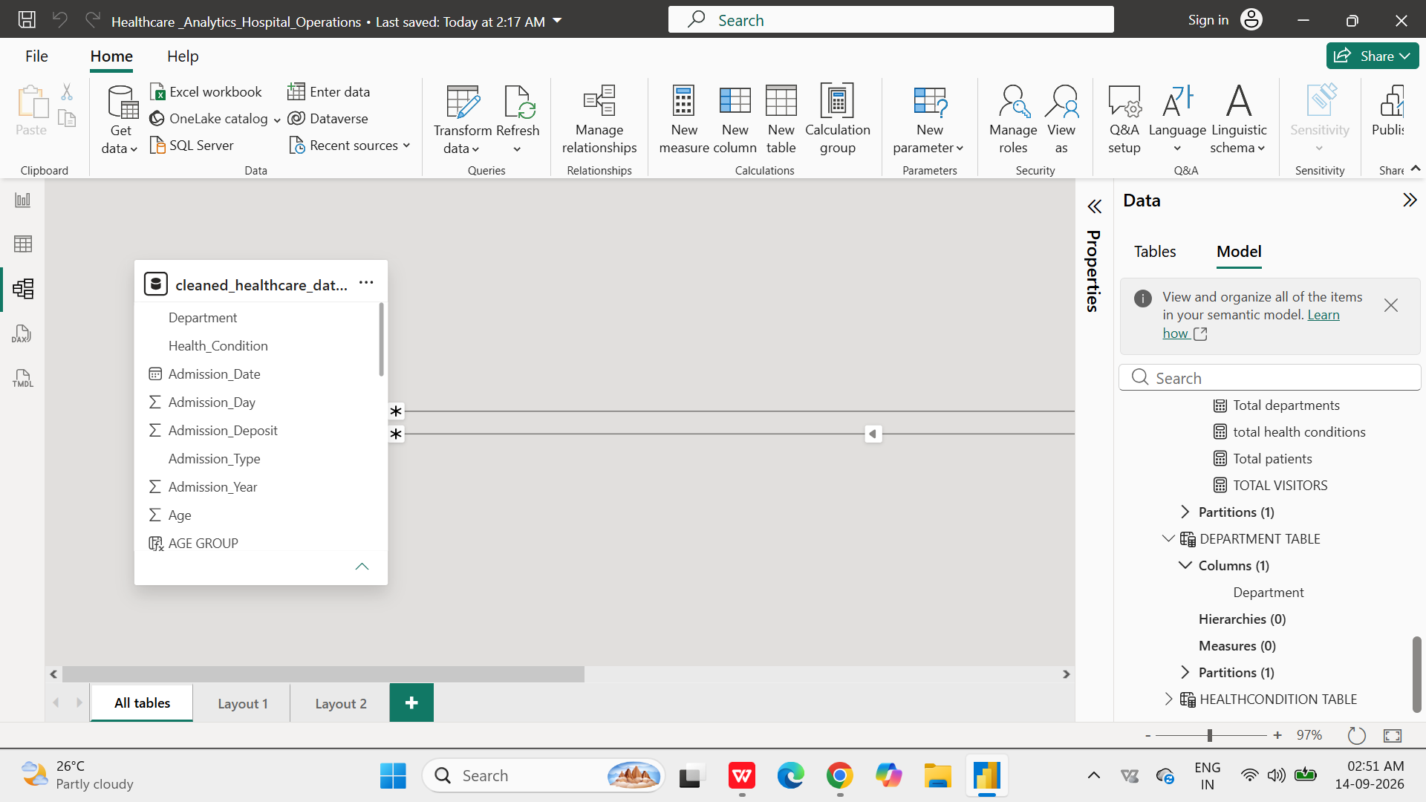

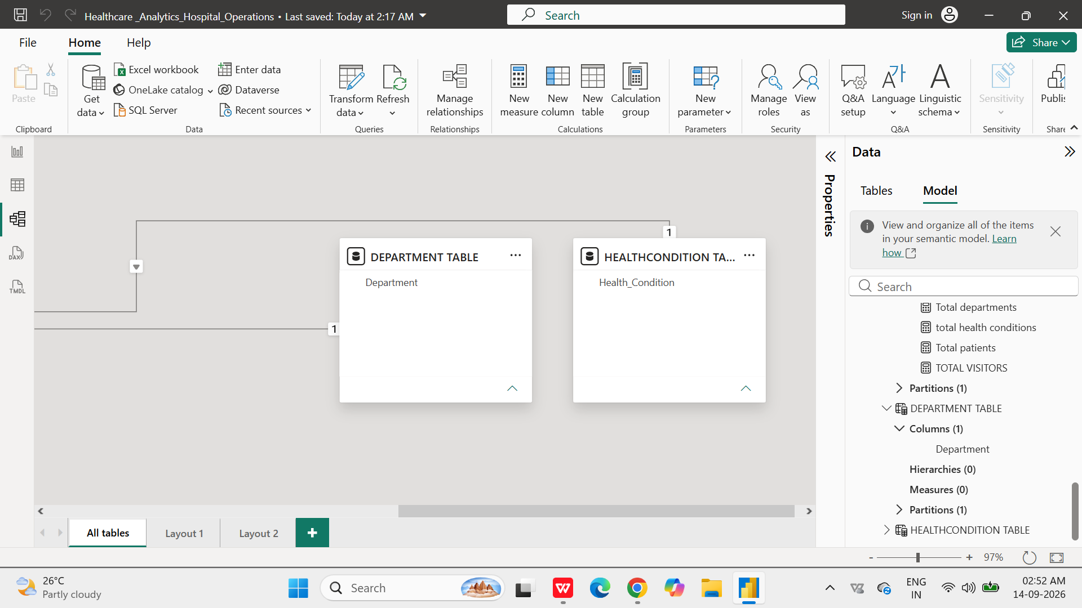

- Calculated Columns & DAX Measures: Implemented DAX formulas for key metrics, such as total admissions .
- Report interactive Layout using Drill-down, Filters and slicers

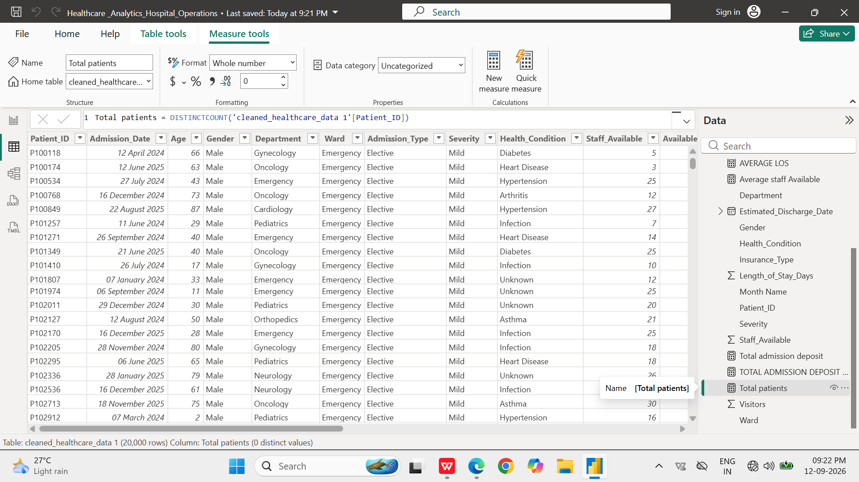

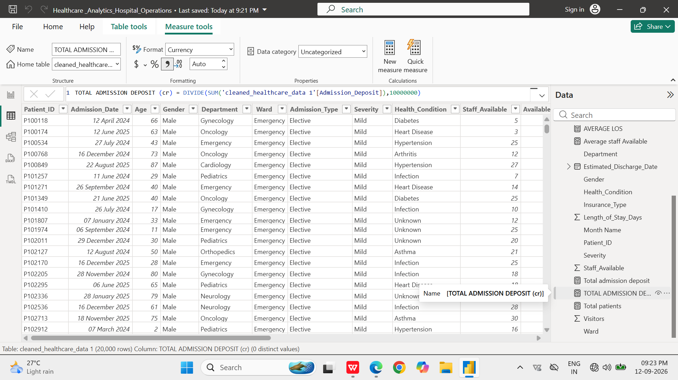

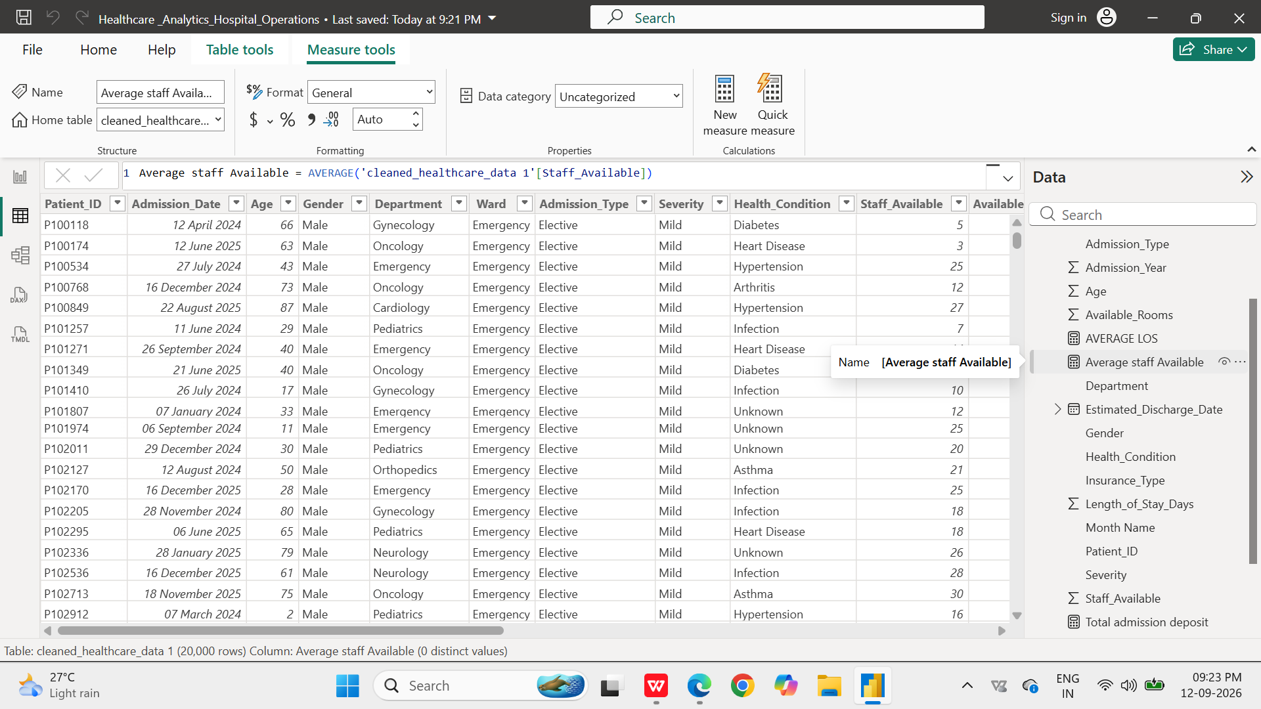

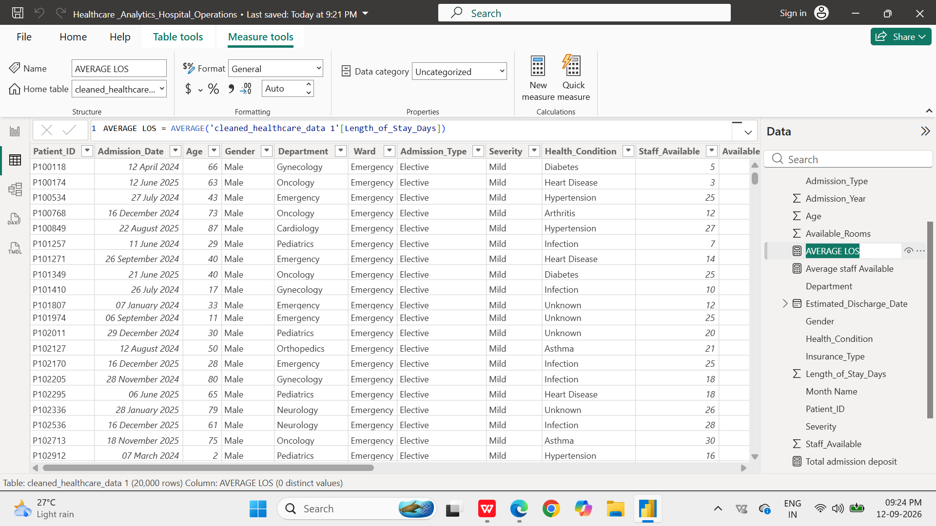

8. Analysis and Visualizations (Power BI AND PYTHON)
Dashboard Features:
- Multiple Visualizations based on problem statement: Univariate analysis charts, Bivariate analysis charts, multivariate analysis charts, KPI cards, and tables to communicate insights. List are
Count plot, histogram, box plot, scatter plot, bar plot, correlation heat map, pair plot, grouped analysis, pivot tables, advanced plot.

Patient distribution by gender
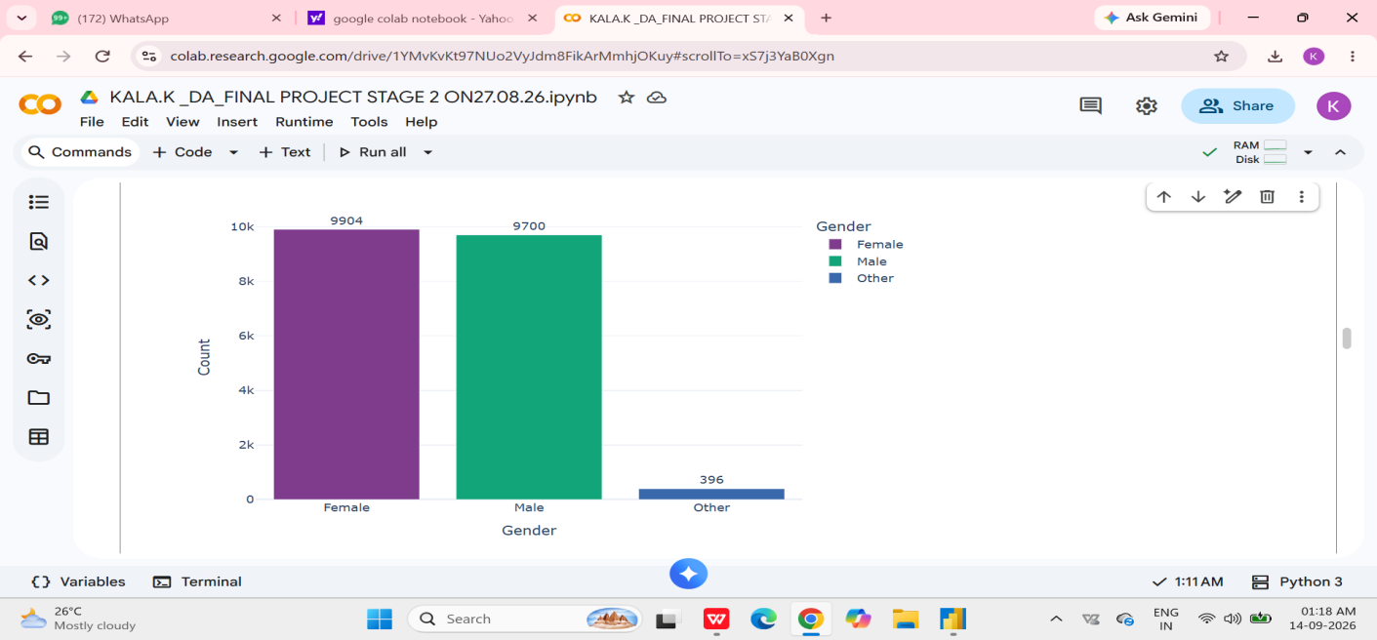
INSIGHTS Key Data Insights
- Balanced Primary Demographics: Patient admissions are almost evenly split between Female (9,904 patients) and Male (9,700 patients), showing balanced utilization across major demographic segments.
- Inclusive Minority Representation: The Other category accounts for 396 patients (~2% of total admissions), representing non-binary, gender-diverse, or non-disclosed patient profiles.

BIVARIATE ANALYSIS-LENGTH OF STAY BY ADMISSION TYPE
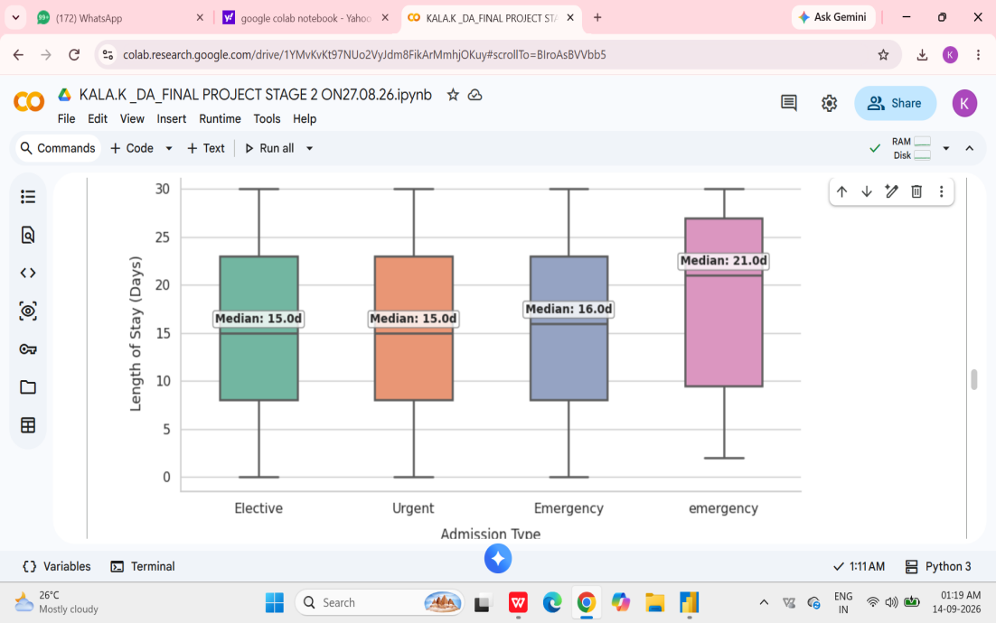

This bivariate box plot illustrates the relationship between admission urgency categories (Elective, Urgent, Emergency) and the hospital length of stay measured in days across 20,000 admission records.
- Admission type alone does not cause significant variance in stay duration, directing further analysis toward medical severity or department types.
MULTIVARIATE ANALYSIS :AVERAGE LENGTH OF STAY BY DEPARTMENT AND ADMISSION TYPE

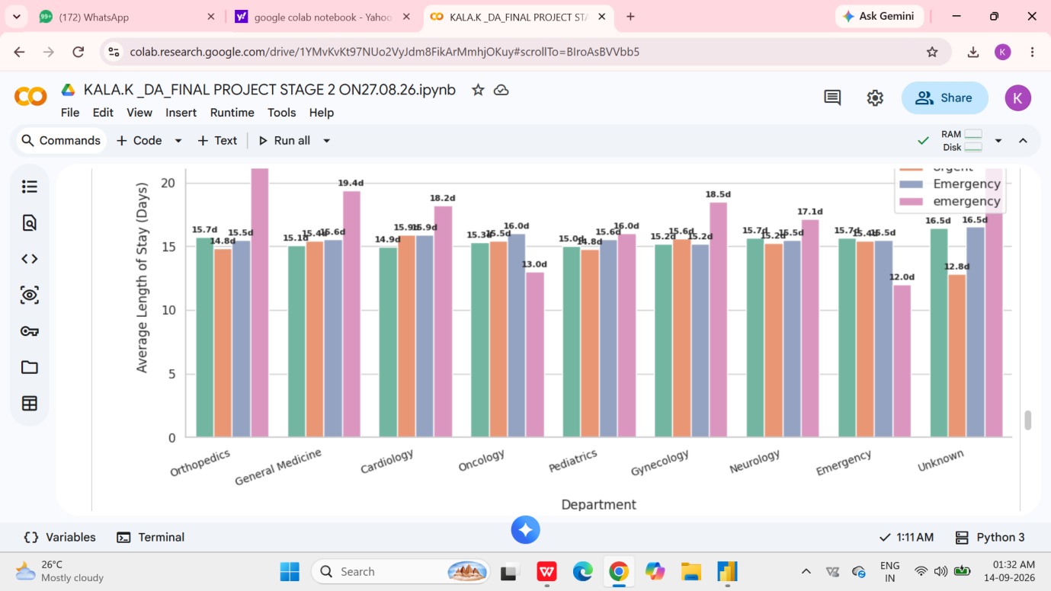

This grouped bar plot compares the mean length of stay (in days) across various medical departments (such as Orthopedics, General Medicine, Cardiology, Oncology, Pediatrics, Gynecology, Neurology, Emergency, and Unknown), segmented by admission channel (Elective, Urgent, and Emergency)
The average length of stay remains constant at approximately 15 to 16 days across almost all combinations of clinical departments and admission channels.
The Unknown department category shows slightly more variation (with Urgent stays averaging ~13 days), but overall stay durations across major departments remain consistent.

- Report interactive Layout using Drill-down, Filters and slicers
Interactive Dashboard Layout
The Power BI dashboard was designed with an interactive layout to enable users to explore healthcare operational data efficiently. Interactive features such as drill-down, slicers, and filters were incorporated to provide both high-level and detailed views of the data.
- Drill-down,
- Filters
- Slicers
- Interative visuals , KPI, CARDS
The interactive layout enables hospital administrators to move from overall performance to detailed analysis, compare different hospitals or departments, identify workload and performance variations, and obtain actionable insights for manpower planning, resource allocation, and operational improvement.

POWER BI DASH BOARD SCREEN SHOT
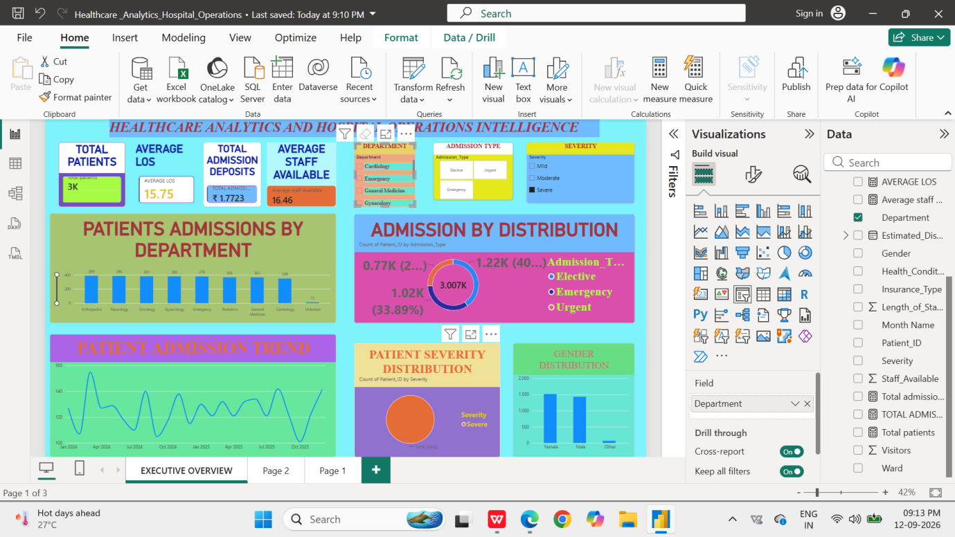

EXECUTIVE OVERVIEW PAGE -1
KPIS USED
✅ Total Patients- measures overall admission /admission volume -
✅ Average LOS-measures average duration of hospital stay
✅ Total Admission Deposits-shows total admission related deposit value
✅ Average Staff Available-indicates average staff availability associated with patient records
SLICERS USED
✅ Department slicer- can see patient volume, LOS, staff availability, admission pattern,severity , Gender distribution
✅ Admission Type slicer-elective, emergency , urgent
✅ SEVERITY SLICER -mild, moderate , severe
CHARTS USED
✅ Patients Admissions by Department
Chart -column chart
Usage
Shows the patient workload across departments.
Hospital Administrator Insight
The administrator can identify:
High-volume departments
Low-volume departments
Departments requiring greater staffing
Departments requiring more beds/resources
Workload imbalance between departments
Management decision
If one department consistently has substantially higher patient volume, management can consider:example emergency dept high volume , in elective at mild severity level , staff available average -16%
staff allocation → bed allocation → equipment allocation → duty roster planning.
✅ Admission Distribution
Chart - Donut chart
Usage
Shows the proportion of patients according to admission type.
Administrator Insight
This helps determine whether the hospital workload is predominantly:
Emergency-high
Urgent
Elective
Management decision
A high proportion of emergency admissions could indicate the need for:
Adequate emergency staffing
Faster triage
Emergency bed availability
Resource readiness
Appropriate shift planning
✅ Patient Admission Trend
Chart -Line chart
Usage
Shows how patient admissions change over time.
Administrator Insight
The administrator can identify:
Increasing admission periods
Decreasing admission periods
Admission peaks
Low-demand periods
Possible workload fluctuations
Management decision
Admission trends can support:
staff roster planning + bed planning + inventory planning + operational preparedness.

✅ Patient Severity Distribution
Chart -pie chart
Usage
Shows the distribution of patients according to clinical severity category.
Administrator Insight
This helps management understand the clinical workload, not just the number of patients.
For example: emergency
High patient count + high severity → greater clinical resource requirement.
High patient count + predominantly mild severity → different resource requirement.
Management decision
Severity distribution can support:
Staff deployment
Bed planning
Monitoring requirements
Nursing workload planning
Critical-care resource planning
✅ Gender Distribution
Chart - column chart
Usage
Shows the patient distribution by gender.- female -high admission
Administrator Insight
It provides a basic demographic profile of the hospital's patient population.
This can support:
Service planning
Patient demographic analysis
Department-level demographic comparison
Resource planning where gender-specific services are relevant
summary
"Page 1- an EXECUTIVE OVERVIEW . It provides a high-level view of patient volume, average length of stay, admission deposits and staff availability. Department and admission-type and severity slicers allow administrators to drill into specific operational segments. Department-wise admissions identify workload concentration, while the admission trend highlights changes in patient demand over time. Severity distribution provides insight into clinical workload, and gender distribution gives a basic demographic profile. Together, these visuals support data-driven decisions related to staffing, bed utilization, resource allocation and operational planning."

DASH BOARD 2 - PATIENT AND ADMISSION ANALYSIS
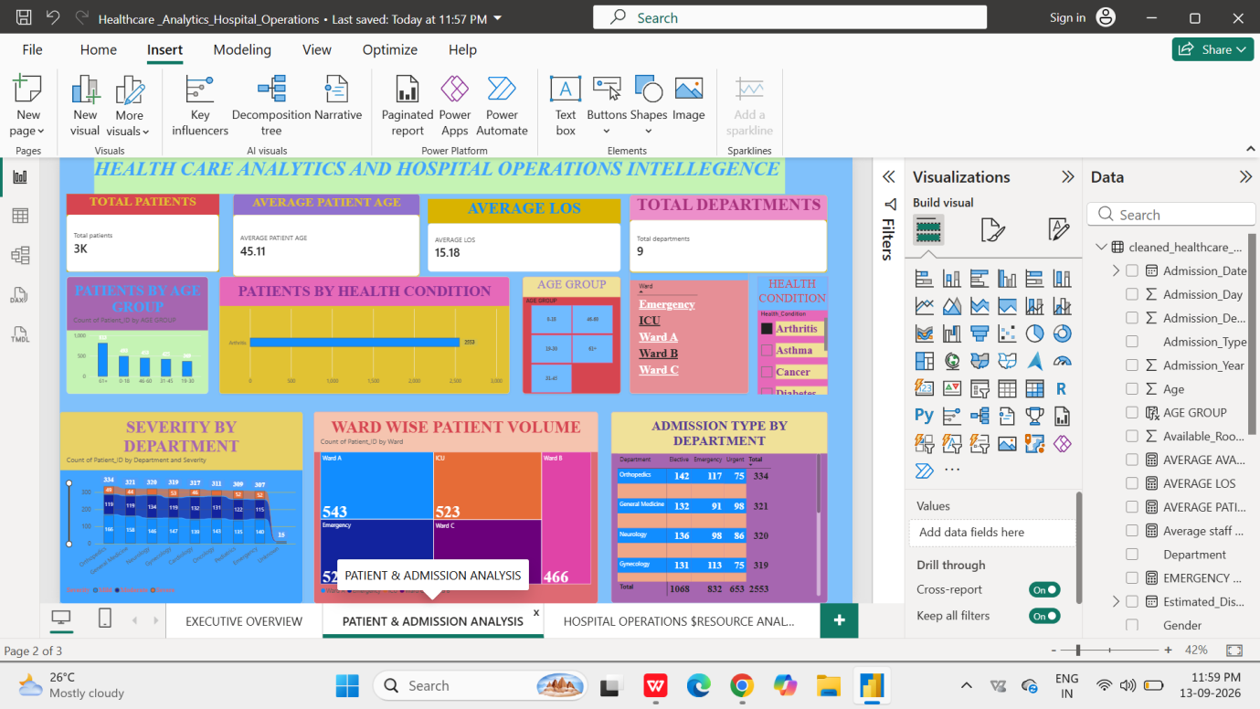

- KPI CARDS
Total patients - over all patient volume
Average age -understand patient age profile
Average LOS-understand duration of hospitalization
Total Departments -shows breadth of department activity
- SLICERS
Age group
0–15
16–30
31–45
46–60
61+
Usage
Allows the administrator to analyse patient characteristics by age group.
Ward
Emergency
ICU
Ward A
Ward B
Ward C
Usage
Allows the administrator to focus the entire page on a particular ward.

Health condition
Arthritis
Asthma
Cancer
Diabetes
Heart disease
Hypertension
Infection
Usage
Allows administrators to analyse a particular clinical condition.
CHARTS
- PATIENTS BY AGE GROUP
Chart -column -understand age distribution
- PATIENTS BY HEALTH CONDITION
Chart - Horizontal bar -identify major health conditions
- SEVERITY BY DEPARTMENT
Chart -stacked column -identify clinical workload by department
- WARD WIS EPATIENT VOLUME
Chart -Tree map- compare ward work load
- ADMISSION TYPE BY DEPARTMENT
Chart-matrix-understands admission patterns by department

PAGE 2 - INSIGHTS
This is the most important part of your analysis report.
Insight 1 — Patient demographics
Patients by Age Group identifies the dominant age groups.
➡️ Helps in patient-care and service planning.
🔹 Insight 2 — Disease burden
Patients by Health Condition identifies which conditions contribute most to hospital workload.
➡️ Helps prioritize clinical resources.
Insight 3 — Clinical workload
Severity by Department combines patient volume with severity.
➡️ Helps identify departments requiring greater clinical attention.
Insight 4 — Ward workload
Ward-wise Patient Volume shows where patients are concentrated.
➡️ Helps with bed and staff allocation.
Insight 5 — Patient flow
Admission Type by Department identifies admission patterns across departments.
➡️ Helps with emergency readiness and operational planning.
Insight 6 — Focused analysis
The Age Group, Ward and Health Condition slicers allow administrators to investigate specific patient segments.
For example:
Select EMERGENCY + 61+ + Diabetes= 462
and the dashboard can show the corresponding patient distribution and admission characteristics, subject to the available data.
summary
“Page 2 PATIENT AND ADMISSION ANALYSIS focuses on patient and admission analytic. It analyses the patient population by age group and health condition and evaluates the distribution of clinical severity across departments. Ward-wise patient volume identifies differences in operational workload, while admission type by department provides insight into patient-flow patterns. Interactive filters for age group, ward and health condition enable administrators to perform focused analysis. These insights can support staffing, bed allocation, resource planning, emergency preparedness and workload management.”

DASHBOARD 3 HOSPITAL OPERATIONAL AND RESOURCE ANALYSIS

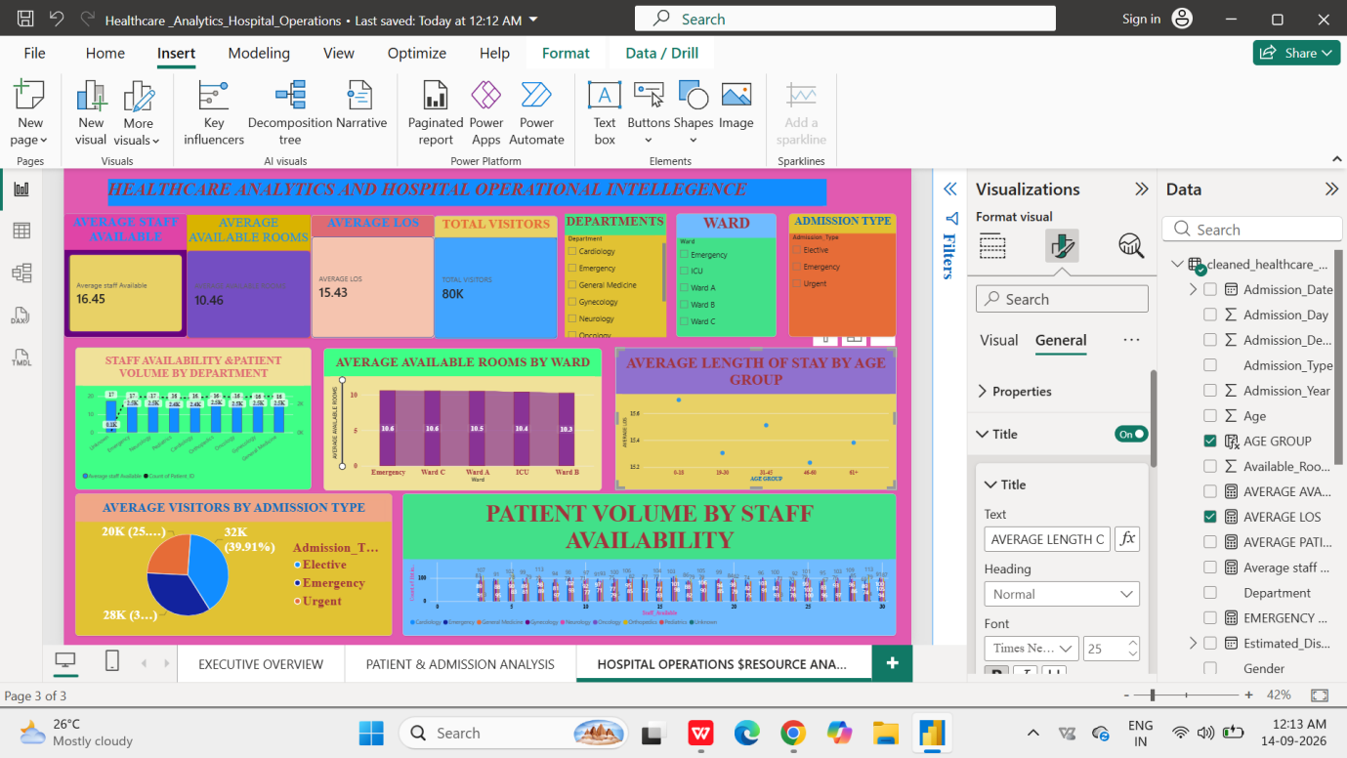
KPI Cards:
Average Staff Available
Average Available Rooms
Average Length of Stay
Total Visitors
Slicers:
Department
Ward
Admission Type
CHARTS
1.Staff Availability & Patient Volume by Department
Line and Clustered Column Chart
Compares staff availability and patient volume across departments to identify departments requiring further workload and resource review.
2.Average Available Rooms by Ward
Ribbon Chart
Compares average room availability across wards and supports ward-level capacity and resource planning.
3.Average Length of Stay by Age Group
Scatter Chart
Examines the relationship between patient age groups and average length of stay to identify patterns in hospitalization duration.
4.Average Visitors by Admission Type
Pie Chart
Shows visitor patterns across admission types and supports visitor-management and patient-support planning.
5.Patient Volume by Staff Availability
Line and Clustered Column Chart
Examines patient volume at different staff-availability levels and supports workload assessment and staffing review.
- Create a consolidated Report /Dashboard.
9. Insights
Key Insights
- Patient workload varies across staff and departments, indicating differences in workload distribution and staffing requirements.
- Staff availability has a direct impact on patient workload. Departments with higher patient volume but comparatively lower staff availability may require better staff allocation.
- Department-wise workload analysis helps hospital administrators identify high-demand departments and plan manpower accordingly.
- Hospital performance differs across facilities and measures, highlighting areas where corrective action and closer monitoring may be required.
- Interactive slicers allow administrators to analyse workload and performance by hospital, department, and other relevant categories.
10.Types of Analysis Used

Four major types of data analysis were used in this project to understand hospital operations and support data-driven decision-making.

1. Descriptive Analysis

Descriptive analysis was used to understand what has happened in the hospital data. It summarizes important information such as patient volume, staff availability, departmental workload, hospital performance, and key performance indicators (KPIs).

Examples: KPI cards, totals, averages, department-wise patient workload, and hospital-wise performance.

2. Diagnostic Analysis

Diagnostic analysis was used to understand why certain patterns or variations occurred in the data. Different departments, hospitals, staff availability, and workload levels were compared to identify possible operational gaps and areas requiring attention.

Examples: Comparing patient workload with staff availability, analysing departmental differences, and identifying performance variations.

3. Predictive Analysis

Predictive analysis was used to identify possible future trends and workload requirements based on the available historical data. The analysis can help hospital administrators anticipate periods of increased workload and plan manpower and resources accordingly.

Examples: Observing workload trends and using historical patterns to support future staffing and resource planning.

4. Prescriptive Analysis

Prescriptive analysis focuses on what actions can be taken based on the findings. The insights generated from the dashboard were used to recommend appropriate actions such as improving staff allocation, monitoring high-workload departments, strengthening data quality, and optimizing resource utilization.

Examples: Recommendations for manpower allocation, workload management, resource planning, and continuous performance monitoring.

Overall Analytical Approach

The four levels of analysis—Descriptive, Diagnostic, Predictive, and Prescriptive—provide a structured approach from understanding the current situation to identifying causes, anticipating future requirements, and recommending appropriate actions. This approach helps convert healthcare data into actionable insights for hospital administrators and supports evidence-based decision-making.
- SUMMARY
The project analysed healthcare operational data using Python and Power BI. Data cleaning, preprocessing, analysis and visualization were performed to examine patient workload, staff availability, departmental performance and hospital-level indicators. Interactive dashboards containing KPIs, charts and slicers were developed to provide a comprehensive view of hospital operations.
- Conclusions
The project demonstrates that healthcare analytics can transform raw hospital data into actionable insights. The developed dashboard can support hospital administrators in staff allocation, workload management, resource planning, performance monitoring and evidence-based decision-making. Overall, the project highlights the value of combining Python and Power BI to improve operational efficiency and support continuous improvement in healthcare services.
- Recommendations
The integration of python and Power BI proved effective for end-to-end data analysis, from raw data to visual reporting.
the following recommendations are proposed for improving hospital operations and supporting data-driven decision-making:
1.Optimize Staff Allocation
Hospital management should review patient workload and staff availability regularly and allocate staff according to workload requirements across departments.
2.Monitor High-Workload Departments
Departments with consistently high patient volumes should be closely monitored to prevent staff overburdening and maintain quality of patient care.
3.Improve Resource Planning
Hospital resources such as manpower, equipment, beds, and other operational facilities should be planned based on patient demand and workload trends.
4.Strengthen Performance Monitoring
KPI- based monitoring should be conducted regularly to identify departments or facilities requiring corrective and improvement measures.
5.Improve Data Quality
Missing, incomplete, or inconsistent data should be minimized through standardized data-entry procedures and regular data validation.
6.Monitor Workload Trends
Historical and current workload trends should be analyzed to anticipate periods of increased patient demand and plan resources proactively.
7.Use Dashboard-Based Decision Making
Hospital administrators should use the interactive Power BI dashboard for regular monitoring, comparison, and evidence-based operational decisions.
8.Conduct Periodic Review
The dashboard and performance indicators should be reviewed periodically so that emerging operational issues can be identified early and appropriate action can be taken.
9.Support Continuous Quality Improvement
The insights generated from the analysis can be used to identify gaps, implement corrective actions, and evaluate whether improvements have resulted in better operational performance.

